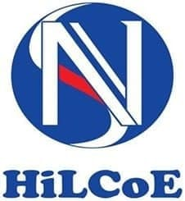

**HiLCoE SCHOOL OF COMPUTER SCIENCE AND TECHNOLOGY**

**Web Design and Development**

**GROUP ASSIGNMENT**

**SUBMMITED TO: INSTRUCTOR ZELALEM**

**DRB2101**

**NAME ID**

1. **MIKIYAS BIRHANE ---------------------------**
2. **MUNIR ALI ------------------------- WE3800**
3. **PENEAL FELEKE ------------------------- XJ5392**
4. **YEABSIRA TESFAYE ------------------------- EL1314**

**3.What kind of internet offers does our ISP provides for us now? For organizations and individuals?**

* ADSL/Broadband Internet:
* Ethio-Telecom's Fixed Broadband Internet service is one of the services that provides internet packages with wired connectivity. Depending on the intended speed and other conditions, it can be delivered via copper or fiber.
* Ethio-Telecom offers two options for this service:

1. Limited Fixed Broadband Internet: is a volume-based packaged service aimed primarily at household consumers.
2. Fixed Broadband Internet with Unlimited Volume: It has an unlimited volume and is sold with a fixed monthly rent and several access speed options.

* Unlimited Fixed Broadband Internet Residential Customers:
* Etho Telecom business internet service is provided through wired and wireless connections with a speed starting from 256 Kbps to the business community.
* Fixed Broadband Unlimited -Copper/Fiber
* Fixed wireless Broadband – Aironet/Radwin
* Local FBB Wired and Wireless MPLS-VPN
* Cell/Mobile Internet:
* Mobile Internet Package:
* Ethio mobile internet service is available in 2G, 3G & 4G LTE options. You can get the service either in pay as you go or package mode with Daily, Weekly & Monthly options.
* Mobile Broadband VPN Service
* Fixed Wireless CDMA